MOONLIGHT COFFEE
Store #2 — Seongsu-dong, Seoul
Interior Design Proposal
Floor Plan · Design Concept · Space Plan · Schedule
Customer: Moonlight Coffee (Store #2, Seongsu-dong, Seoul)
Prepared for: Soyul Han, Operations Team
Date: October 28, 2026
Version: Draft for customer review

1. Design Concept
Store #2 carries over the warm wood tone that defines Store #1. The concept wraps the 12 m × 9 m (approximately 108 m²) space in natural wood and soft, warm light, creating a calm, inviting atmosphere that glows from morning through the late night — the "Moonlight" mood the brand is named for. The hall provides seating for about 40 customers, while the back-of-house rooms (bean storage, staff lounge, restroom) are arranged compactly so the front-of-house feels open and uncluttered.
Mood
- Warm, calm and inviting — a quiet "Moonlight" glow that works for both day and late-night hours
- Continuity with Store #1, so regulars feel the same warmth at the new location
- Open hall with clear sightlines to the bar; back-of-house rooms tucked quietly away
Materials
- Warm wood veneer (oak / walnut tone) on the flooring, wall panels and bar front
- Natural stone countertop at the order and coffee bar
- Brass accents with matte-black hardware
- Soft warm-white lighting (approximately 2700 K) for the "Moonlight" ambience
- Warm neutral wall palette (cream, taupe, walnut brown)

2. Space Plan
Total floor area is approximately 108 m² (12 m × 9 m). The hall is allocated about 40 customer seats as requested.
Room | Area | Use
Hall | 56 m² | Customer seating
Bar | 16 m² | Order and coffee bar
Storage | 12 m² | Bean storage
Staff Lounge | 12 m² | Staff lounge
Restroom | 12 m² | Restroom
Total | 108 m² | —

3. Floor Plan
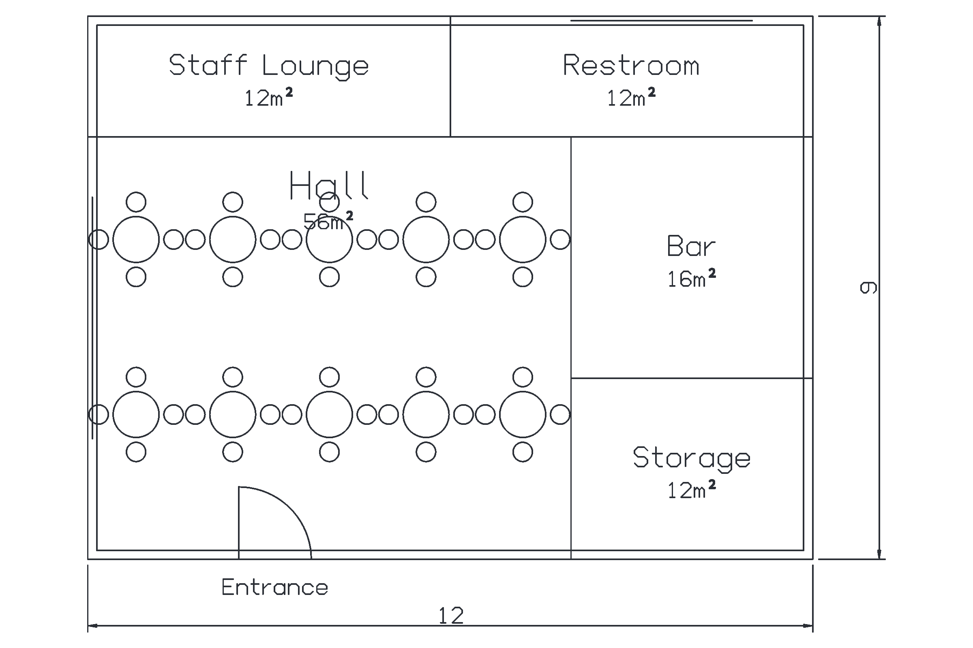
Figure 1. Store #2 floor plan (12 m × 9 m, total approx. 108 m²).

4. Schedule and Next Steps
Target: opening of Store #2 in March 2027, as requested. Indicative schedule below.
Phase | Period | Description
1. Proposal & quote review | Oct 28 – Nov 6, 2026 | Customer reviews the proposal and quote; scope and budget confirmed
2. Detailed design | Nov 9 – Dec 18, 2026 | Final floor plan, material and fixture selection, 3D renders for approval
3. Procurement | Dec 2026 – Jan 2027 | Order custom furniture, bar counter and building materials
4. Construction | Jan 5 – Feb 26, 2027 | Partitioning, wood finishing, electrical and lighting, furniture installation
5. Handover & opening | Early Mar 2027 | Punch list, final cleaning, equipment installation, opening
Next steps
- Review and approve the proposal and quote by Friday, November 6, 2026.
- Confirm the material palette (wood species, stone, lighting tone) and budget range.
- Schedule a site survey of the Seongsu-dong premises and a design-development kickoff meeting.
- After approval, we will issue detailed drawings, 3D renders and the full construction schedule.

